**https://www.journaldunet.com/solutions/cloud-computing/1208931-avec-docker-ee-2-0-docker-fait-sa-revolution-et-integre-kubernetes/**

[**Spring Cloud Incubator**](https://github.com/spring-cloud-incubator/spring-cloud-kubernetes)

<https://github.com/spring-cloud-incubator/spring-cloud-kubernetes>

### Features

* [DiscoveryClient for Kubernetes](https://github.com/spring-cloud-incubator/spring-cloud-kubernetes#discoveryclient-for-kubernetes)

Ce projet fournit une implémentation de Discovery Client pour Kubernetes. Cela vous permet d'interroger les endpoints Kubernetes (voir services) par nom. Un service est généralement exposé par le serveur API Kubernetes sous la forme d'une collection de endpoints qui représentent les adresses http, https auxquelles un client peut accéder à partir d'une application Spring Boot exécutée en tant que pod.

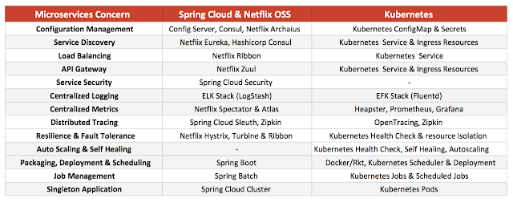

EN :  It provides services for configuration management, service discovery, load balancing, tracing, metrics, singletons, scheduled jobs on the platform level and outside of the application stack. The application doesn't need any library or agents for client side logic and it can be written in any language.

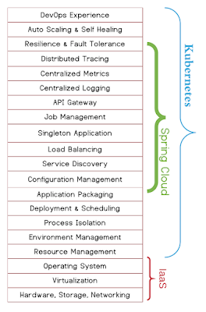

* [KubernetesClient autoconfiguration](https://github.com/spring-cloud-incubator/spring-cloud-kubernetes#kubernetesclient-autoconfiguration)
* [PropertySource](https://github.com/spring-cloud-incubator/spring-cloud-kubernetes#kubernetes-propertysource)
* [ConfigMap PropertySource](https://github.com/spring-cloud-incubator/spring-cloud-kubernetes#configmap-propertysource)
* [Secrets PropertySource](https://github.com/spring-cloud-incubator/spring-cloud-kubernetes#secrets-propertysource)
* [PropertySource Reload](https://github.com/spring-cloud-incubator/spring-cloud-kubernetes#propertysource-reload)
* [Pod Health Indicator](https://github.com/spring-cloud-incubator/spring-cloud-kubernetes#pod-health-indicator)
* [Transparency](https://github.com/spring-cloud-incubator/spring-cloud-kubernetes#transparency) (its transparent whether the code runs in or outside of Kubernetes)
* [Kubernetes Profile Autoconfiguration](https://github.com/spring-cloud-incubator/spring-cloud-kubernetes#kubernetes-profile-autoconfiguration)
* [Ribbon discovery in Kubernetes](https://github.com/spring-cloud-incubator/spring-cloud-kubernetes#ribbon-discovery-in-kubernetes)
* [Zipkin discovery in Kubernetes](https://github.com/spring-cloud-incubator/spring-cloud-kubernetes#zipkin-discovery-in-kubernetes)
* [ConfigMap Archaius Bridge](https://github.com/spring-cloud-incubator/spring-cloud-kubernetes#configmap-archaius-bridge)